**ASSIGNMENT -3 (C Language)**

1. **Display This Information using printf**
2. **Your Name 2. Your Birth date 3. Your Age 4. Your Address.**

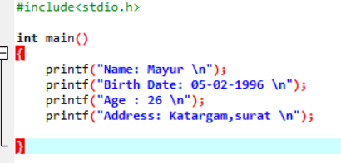

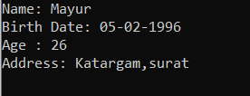

1. **Write a program to make Simple calculator (to make addition, subtraction, multiplication, division and modulo).**

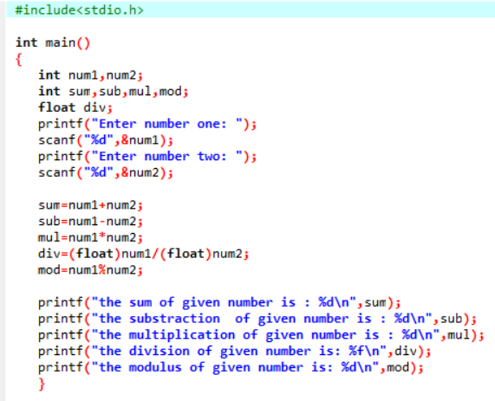

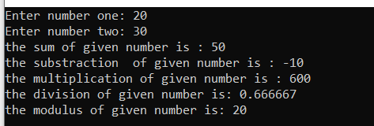

1. **WAP to find area of circle, rectangle and triangle.**

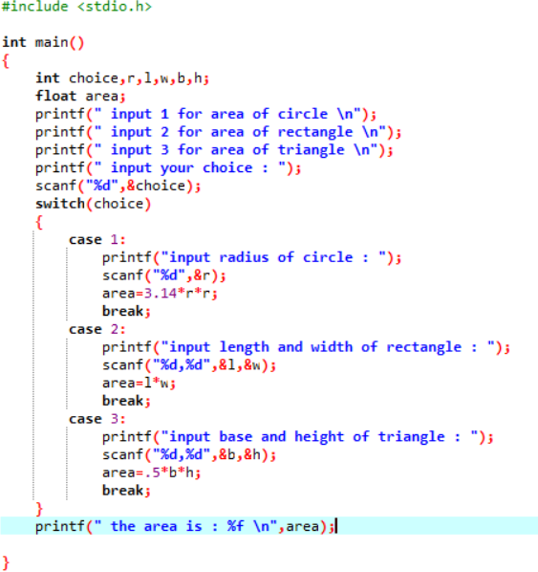

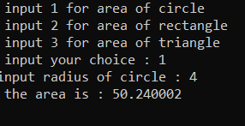

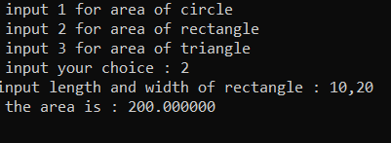

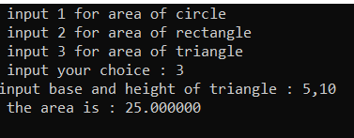

1. **WAP to find simple interest.**

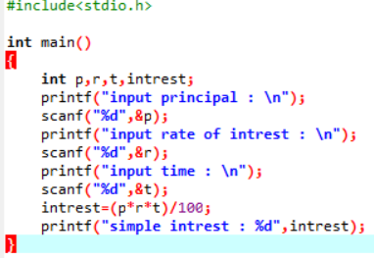

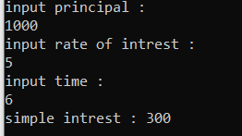

1. **WAP to check if the given year is a leap year or not.**

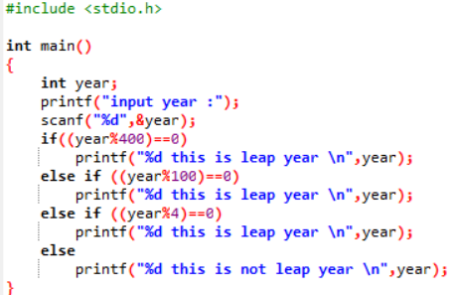



1. **WAP to convert years into days and days into years.**

